# 

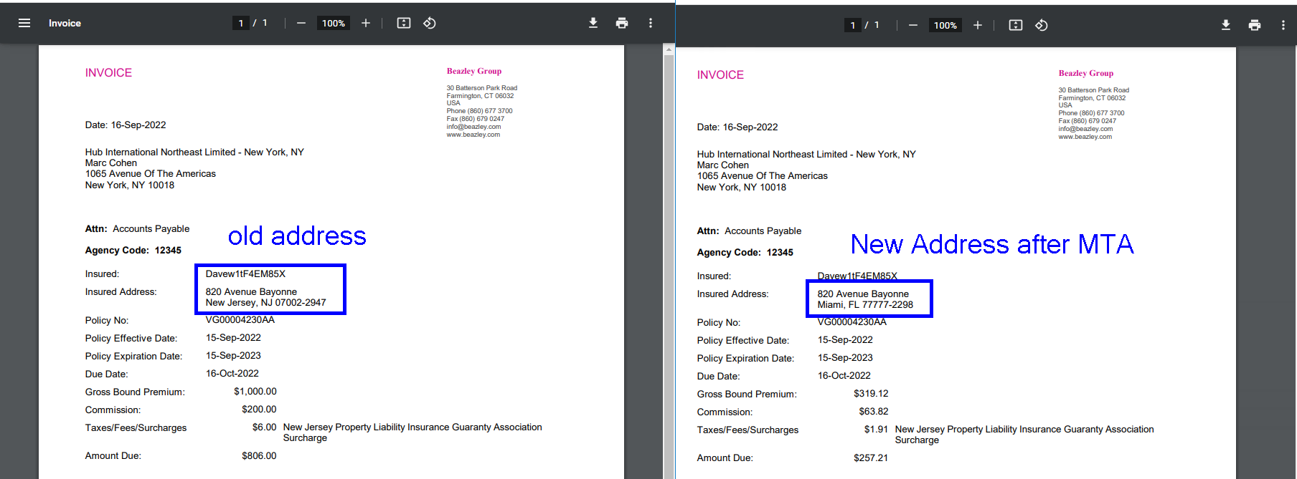

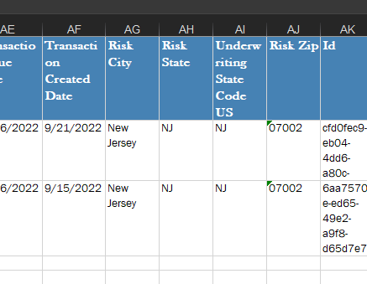

When the address is changed in an issued taxable state policy (in this case NJ) to any other State (i.e. FL in this case) and there is and MTA changing the premium (this is done to get the new invoice), a new invoice is generated with the new address, but the new premium gets calculated still applying the tax from the original state (NJ in this case = 0.6% if it is before 10/01/2022). Besides, the new financial info and the address change should be reflected in LES with the new address and new premium rated for the new state.

Example:

In the original **NJ** policy:

(Quote Option was $1000) = (**$1000 Total Premium**)

Tax charged = ($1000 x 0.6%) = $6

Change the state, in this case I used **FL**, and Perform and (MTA adding $319.12 in this case), so

(New Quote Option is $1000 + $319.12) = (**$1319.12 New Total Premium**)

Tax charged (In this case should use the FL tax, but it is still using NJ’s tax = 0.6%)

($319.12 x 0.6%) = $1.91 as you can see in the invoice.

In the case it is changing from a taxable to a non taxable state, the new invoice should not show any tax or fee. You can see in the attached evidence, when the policy address changed form NJ to IL, the last invoice still calculates the tax even though the address shows it is IL

Steps to reproduce:

* Have an issued CA policy (remember the policy number). It would be a BMT one.
* Open in Insight the insured name of the policy and edit the address (change the state (any), the city and the zip code), and save.
* Look for the insured name in GC and go to policies tab and find and select the policy.
* Amend the policy and hit continue without changing the effective date for the MTA. Once you enter to the amend mode, you will see in red letters the change in the address in the “Insured Information” section in the “common” tab.
* Go to “Bezley Mediatech” tab and then go to the “quote options” and change the original option for other value, in order to generate a total premium change. Then, save and exit.
* Open the new invoice and compare it with the first invoice. You will notice that the address is changed, but the premium calculation still carrying the $90 form CA.
* Open LES and look for the policy. You will see 2 entries: the “new business” that should have the original address information, and the “Additional Premium” that should be showing the new address information. This info should match the information you have in the invoices. Also, LES shows the premium calculation matching with the invoices info.

Actual result:

The new entry generated in LES after the MTA is created, is showing the old address information and the Invoice info with carrying the $90 from CA.

Expected result:

The new entry generated in LES after the MTA is created, should have the new address information (City, State and Zip), and the financial info should be reflecting the taxes of the new state selected in Insight.